12/8/2019

Venkata Deepak Yammanur Z1858941

Nikhil Peddada Z1857203

**Stock Trading Analysis**

***OMIS 670 Social Media Analytics***

**Summary**

Our project is on Stock Trading analysis on two top tech giants Apple (APPL) and Microsoft (MSFT) and news summary featuring in New York Times during the same period. We performed time series analysis of these companies for each quarter of the year. So, investors can have an insight which quarter to invest in the company to get the profit. Companies can know which quarter of the year are in loss and what are the factors responsible for it. With the help of our analysis both the investors and companies can have an insight on the stock trading. Calculated the sentiment score based on the news of those companies to know which company has positive sentiment and also to know if news has a impact of stock closing price of the company.

We further analyzed topics from topic modelling for the news of the companies. Using R language and some preprocessing techniques topic modelling was performed and using word cloud visualization to know which terms have highest frequency. Based on the term’s companies can grow their business. With these recommendations’ investors can sell or buy their stocks and companies can concentrate on their factors for their loss in their stocks.

**CONTEXT**

Apple and Microsoft are one of the American multinational technology company which has stock price since 1984 and 1986 respectively. Apple designs, develops and sells consumer electronics, computer software and online services such as iTunes store, Mac, Appstore, apple music, iPhone etc. Apple is well known for its size and revenues with a worldwide revenue of $265 billion for the 2018 fiscal year. Microsoft develops, manufactures, licenses, supports, and sells computer software, consumer electronics, personal computers, and related services. Its best known software products are the Microsoft Windows line of operating systems, the Microsoft Office suite, and the Internet Explorer and [Edge](https://en.wikipedia.org/wiki/Microsoft_Edge) web browsers. Microsoft has a total revenue of $125.8 billion for the 2018 fiscal year.

The New York Times is an American newspaper founded in in 1851 which is ranked 18th in the world circulation of News Papers. Daily it concentrates on the stock prices and news of the several top tech giants.

**Dataset**

The dataset we used for analysis is about Stock prices of Apple and Microsoft and news related in that time period from The New York Times.

**Variables in our dataset**

Company (Apple/ Microsoft), Opening Price, Closing Price, Highest Price, Volume of stocks, Date of stocks, News published in The New York Times.

Source: [www.kaggle.com](http://www.kaggle.com)

**Our Audience**

Our audience are both the investors and the companies. Investors can have an insight to know which company to invest and which quarter to invest or sell the stocks to gain the profit. Companies can know the factors that affect for their stock loss during period.

**Analysis Approach:**

Data Collection into csv, data cleaning : R

Sentiment Analysis : Microsoft Azure, BI

Classification based on Sentiment Score : Excel(positive, negative, neutral)

Topic Modelling : SAS Enterprise Miner

Visualization : Tableau

Word Cloud : R language

**Algorithms Used:**

* LDA (latent Dirichlet allocation) used for topic modelling in SAS Enterprise miner.
* VADAR (Valence Aware Dictionary and sentiment Reasoner) was sued for Sentiment Analysis

**Packages:**

**“Tm”** in R for Tet Mining

**“SnowballC**” in R for Stemming

**“WordCloud”** In R

**Why we used Sentiment Analysis?**

Sentiment analysis sometimes also known as opinion mining, sentiment analysis is the process of contextually mining text to identify and categorize the subjective opinions expressed by the writers. Normally it is used to determine whether the writer's attitude towards a particular topic or product, etc. is positive, negative, or neutral. It is also often use by businesses to help them understand the social sentiment of their brand, product or services while monitoring online conversations in this case Microsoft and Apple. In our case we are focused on the news published by the New York Times and what are the news that are delivering to the public whether it is positive or negative. We used Vader Function to find the sentiment score as it gives values for the text which ranges from 0.1 to 1.0 which we have categorized to the values which are greater than 0.5 is Positive and less than 0.5 as Negative where 0.5 is considered as Neutral.

**Why we used Topic Modelling?**

Large amounts of data are collected every day. As more information becomes available, it becomes difficult to assess what we are looking for. So, we need tools and techniques to organize, search and understand vast quantities of information. Latent Dirichlet Allocation (LDA) is a topic model example and is used to classify text into a specific topic in a document for this project. It constructs a topic by model of text and words by model of subject, modeled as distributions of Dirichlet. Topic Modelling for classifying the relevant keywords of a New York times news into Topics based on the sentiment and weight. It gives an overview of the terms and its frequency also gives us the number of times the term repeated in the whole corpus and number of documents.

**Why we used Word Cloud?**

Word cloud is a graphical representation of the word frequency. The clouds give greater

prominence to words that appear more frequently in the text and the word size is adjusted

accordingly. The words with greater prominence appear bigger in size. From the text obtained

in the newyork time news of both the companies that we are analyzing, word clouds are created by using R where we used “Wordcloud” package. R Functions removes all the commonly used words automatically and gives the word cloud.

**INFERENCES**

1. **Time series analysis of Stock prices of Apple and Microsoft for each quarter in a year (2016) and in detail information of Closing, opening all around the year and Closing price of each quarter.**

**Analysis Report:**

Apple has reached an all-time high of stock price of $119.41 on Oct 24, 2016 and lowest of $90.18 on May 14, 2016.

|  |  |  |
| --- | --- | --- |
| Quarter of the year 2016 | Average Closing Price ( $) | Total Number of Stocks Purchased |
| Q1 | $100.82 | 2,703M |
| Q2 | $100.1 | 2,503M |
| Q3 | $105.85 | 1,846M |
| Q4 | $113.74 | 1,144M |

From the above table we can interpret that during Q4 Apple has its highest stock price which means investors can sell their stocks during that period to gain the profit. Also, total number of stocks purchased in Q4 also very low. For investors to buy the stocks they need to purchase from either first or second Quarter of the year.

Microsoft has reached all- time high stock price of $61 on Oct 25,2016 and lowest of $48 on June 27, 2016.

|  |  |  |
| --- | --- | --- |
| Quarter of the year | Average Closing Price ($) | Total number of stocks purchased |
| Q1 | $53.18 | 1.69K |
| Q2 | $52.55 | 1.88K |
| Q3 | $57.07 | 2.16K |
| Q4 | $59.46 | 1.36K |

From the above table we can interpret that during second quarter of the year Microsoft has its lower average closing price which means investors can buy stocks during that period and during 4th quarter investors interested to sell the stocks can sell to gain the profit.

From the analysis both the companies have highest closing price during the 4th quarter of the year, there could be many reasons behind it one of the reasons may be the closing fiscal year quarter. Companies can prepare an analysis report to know the reason for the lowest stock price during specific quarter of the year for their business growth. Refer fig 1 and 2 for the visualization on stock analysis of Apple and Microsoft respectively.

1. **Does news really have an impact on the stock prices?**

**Analysis report:**

Calculated sentiment score of Apple and Microsoft companies from the news published in The New York Times during the year 2016 using Microsoft Azure and Power BI. With the results of Power BI, we visualize through tableau to know the positive, negative, neutral sentiment. The below table is the sentiment score of the companies

|  |  |
| --- | --- |
| Company | Average Sentiment Score |
| Apple | Positive – 0.9  Neutral-0.5  Neagtive-0.1 |
| Microsoft | Positive- 0.8  Neutral-0.5  Negative-0.2 |

From previous visualization analysis it is stated that apple has highest stock price compared to Microsoft and now we got apple has highest positive sentiment score compared to Microsoft. Which means News has an impact on stock price.

So, from this report Microsoft can concentrate on the factors responsible for negative sentiment score and improve their business for the coming fiscal year. Refer image 3 and 4 for the Sentiment analysis visualization in Tableau.

**Inference 3:**

**What topics are discussing in the news about Microsoft and Apple? Which topic is popular among news for these companies?**

We did topic Modelling for Microsoft and Apple news that are published in The New York Times to help the companies to get to know what are the interesting topics about company that are being published and delivering to people. We Wanted to know is there any impact on the shares of the companies with respect to the news that are being published. After performing the topic modelling and Sentiment analysis for the same time period of news we consider that the following terms of the companies that are performing well. If you see the below image the top 10 words include

Single and multiple topics. As the sentiment in the news is too high, we consider the following terms are doing good for consideration. For Microsoft, technology, US, Windows, Cloud, data are considered to be a positive factor.

For Apple, Watch, iPhone, Service, technology, Sales, devices are considered to be a positive for factors for that particular period of time.

**Microsoft:**

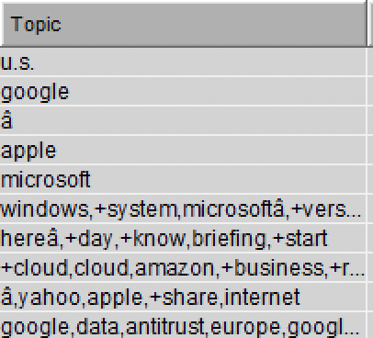

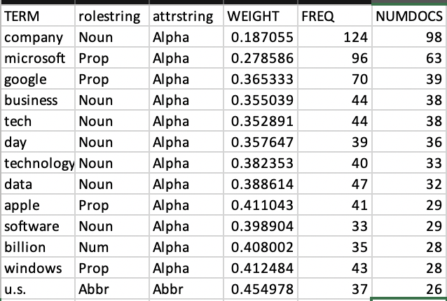

**Apple:**

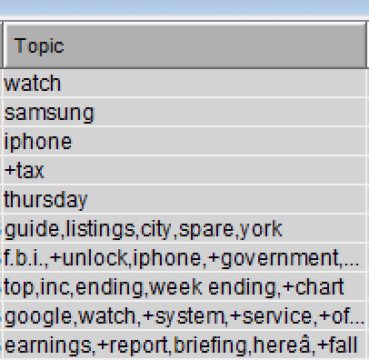

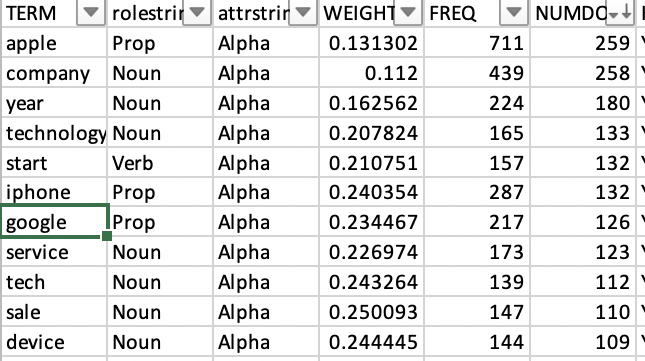

**Recommendations**

1. Investors interested in buying and selling the stocks can view the stock analysis to either buy or sell in that specific quarter of the year. Companies can analyze in which quarter are the stocks are low and what are factors effecting it.
2. Based on the news sentiment score both the companies and investors can know the insight of the stock details.
3. Companies can use topic modelling analysis report to know what the products are, news are highlighted and what are the areas to be improved.

**Appendix:**

**FIG 1: Apple Stock Analysis**

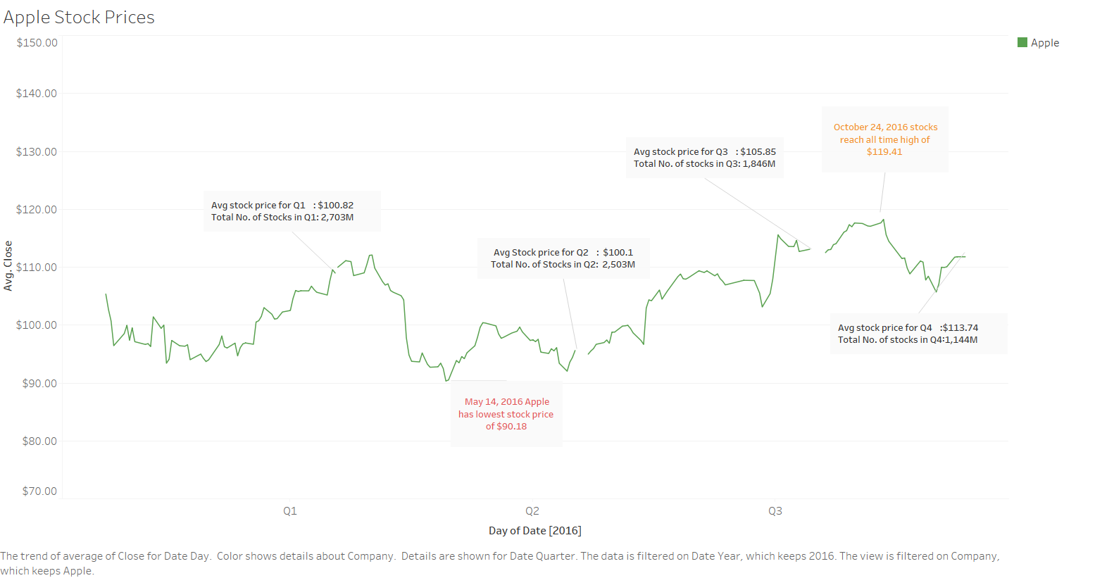

**FIG 2: Microsoft Price Analysis**

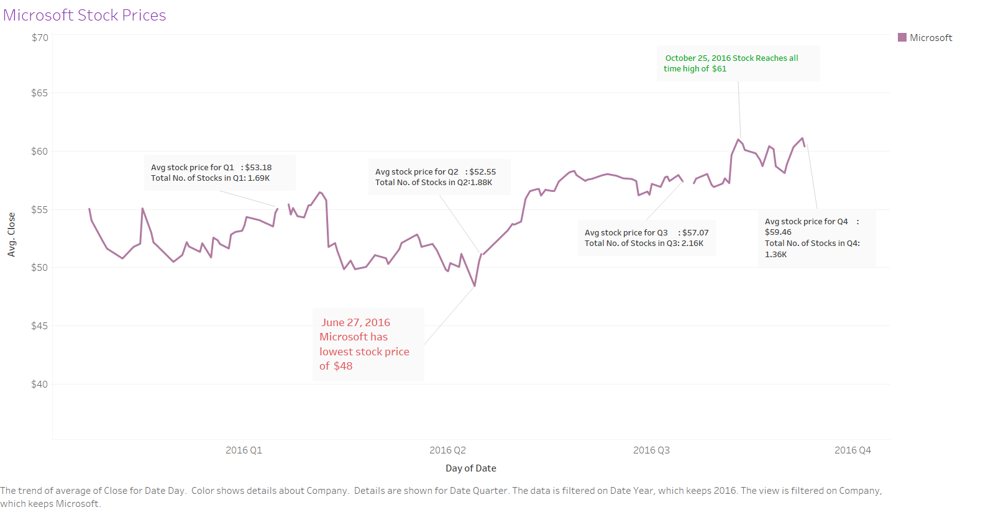

**FIG 3: Apple Sentiment Score**

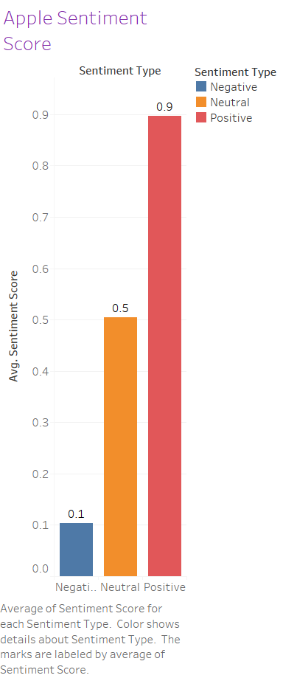

**FIG 4: Microsoft Sentiment Score**

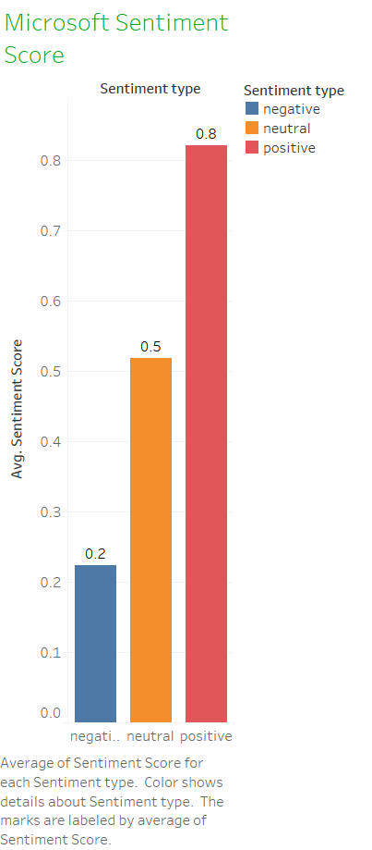

**Code for WordClod in R:**

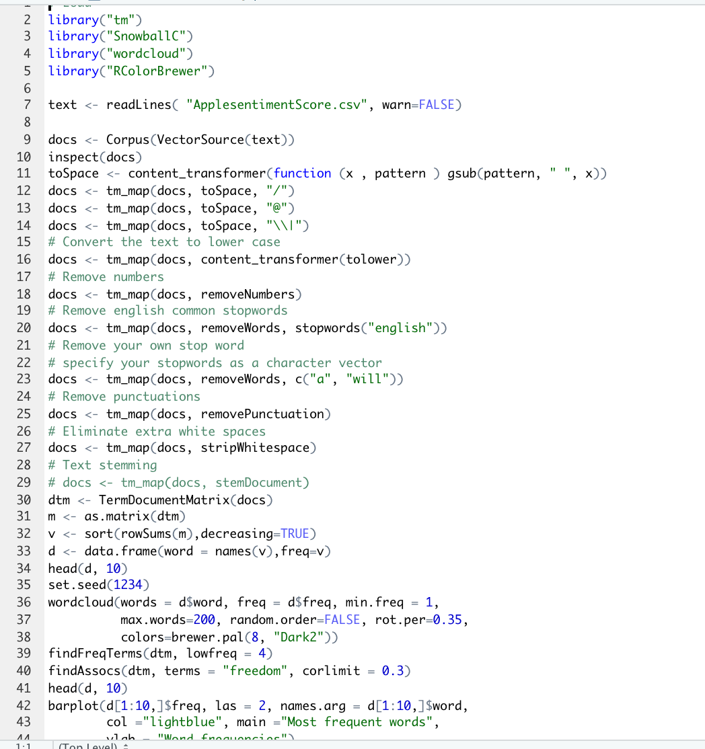

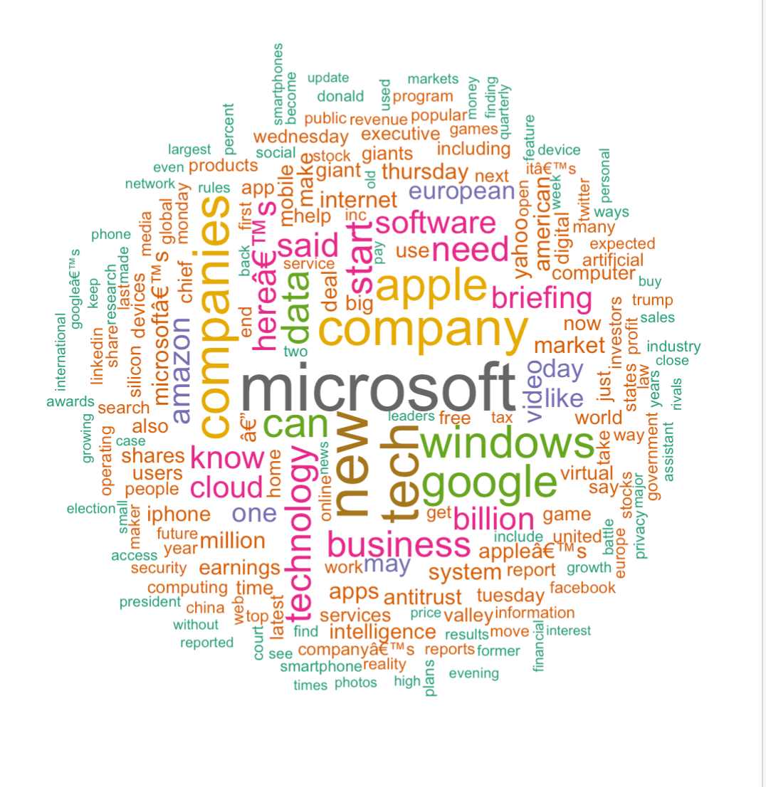



**Word Clod for Apple**

